**Agenda item 14**

**Station Road Bus Shelter adjacent to Wem Recreation Ground**

Following email from resident John and I  inspected the bus shelter, it has always had a slight lean but the lean was more pronounced probably as a result of something hitting it (see picture of damage to main post below) and this has resulted the lowest point between the ground and the bus shelter being 191cm (for comparison the distance from the ground

on the bus shelter across the street is 200cm)

Salop Glass removed the glass and in the interim warning tape was placed on the bus shelter to make people aware of the lower height. (see photo attached).

Insurance informed of potential claim

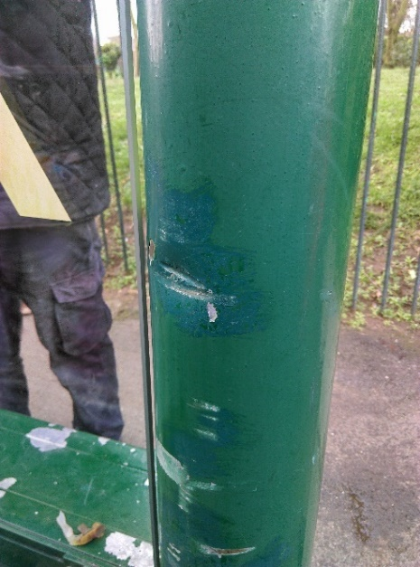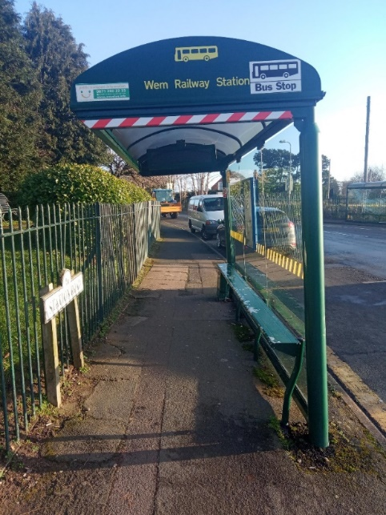

The shelter was removed by contractors on 12.2.20 and investigations are being carried out to see if the shelter can be repaired or not. The seat and electric unit remain.

The repair or replacement of the shelter is covered by the Town Council’s insurance which is subject to a £50 excess.

Quotes for repair to bus shelter or replacement shelter will be presented at the meeting